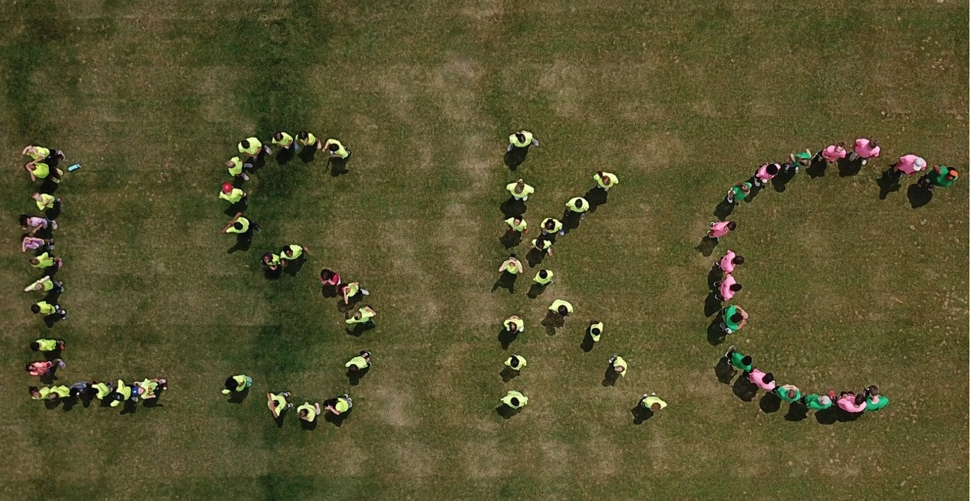 COVID -19 Safety Plan

Lawrence Summer Kids Camp (LSKC) takes the health and safety of our staff and campers very seriously. In response to the spread of COVID-19, a respiratory disease caused by the novel coronavirus. LSKC has developed this COVID-19 Safety Plan as part of our efforts to reduce the potential for exposure to and spread of the coronavirus. This plan is based on information available from the U.S. Centers for Disease Control and Prevention, the Occupational Safety and Health Administration, and the State of Indiana and is subject to change based on further guidance from these and other public health agencies. LSKC will monitor coronavirus related guidance and will communicate any changes to this plan.
All staff should be familiar with this plan, as we count on everyone to do their part to promote a healthy, safe working environment. If you have any questions about the Plan, please contact a Camp Director.
PRECAMP
- Educate staff, campers and their families about when they should stay home and when they can return to camp.
- Staff will receive training in proper hygiene practices and how to teach proper hygiene practices.
- Staff will undergo a virus spreading experiential exercise.
DURING CAMP
Staff and Camper Health Screening Process
LSKC has instituted the following health screening process for all staff and campers
- Symptom Assessment Questionnaires - Each day when arriving at camp, both campers and staff will be screened with a temperature check and by responding to a series of questions to gauge whether they may be exhibiting symptoms consistent with COVID-19 and assess their health risk with regard to COVID-19. Symptoms of COVID-19 include cough, shortness of breath, and difficulty breathing. Additionally, people may have COVID-19 if they exhibit at least two of these symptoms: fever, chills, repeated shaking with chills, muscle pain, headache, sore throat, and new loss of taste or smell. A staff member or camper exhibiting symptoms of COVID-19 will be sent home and not allowed to return until at least 72 hours after recovery from all symptoms.
- Testing and Diagnosis – Any staff member or camper who tests positive for COVID-19 or is diagnosed by a healthcare provider with COVD-19 must not come to camp, but should immediately notify a Camp Director. Any staff member or camper who tests positive for or is diagnosed by a healthcare provider with COVID-19 must stay home for at least 10 days after illness onset (the date symptoms begin) and at least 3 days after recovery (the day symptoms are resolved, including the resolution of fever without fever-reducing medications). Authorization from camper/staff healthcare provider will be required prior to return to camp.
- Staff and campers who have recently had a close contact with a person with COVID-19 should also stay home and monitor their health

Hand Hygiene and Respiratory Etiquette
- Campers will be taught handwashing with soap and water for at least 20 seconds
- Staff and campers are to cover coughs and sneezes with a tissue or to cough/sneeze into their elbow. Used tissues will be thrown in the trash and hands washed or sanitized immediately

Masks/face coverings
- Staff will wear masks during all indoor activities. Staff may wear masks during outdoor activities if social distancing is not possible
- Campers are encouraged, but not required, to wear a mask during indoor activities

Signs & Messages
Posters from the CDC concerning COVID-19 and hygiene will be displayed in highly visible areas around camp.

Maintaining Healthy Environment
- Food service will follow the recommendation of the health department and the
guidelines from Environmental Health and Engineering as distributed by the
American Camp Association (ACA).
- Small groups of campers will remain together throughout the day
- The Program team will implement small group cohorts when small groups are not doing activities by themselves.
- Activities will be held outside as weather permits
- Hand sanitizing stations will be placed in each group area
- Social distancing will be utilized during games and group activities

Enhanced Cleaning and disinfecting Protocols
The following enhanced cleaning and disinfection protocols will be in place for the duration of camp
- The Program team will sanitize program activity equipment, and other items between each use
- Rooms will be cleaned and sanitized between camping sessions.
- Facility bathrooms will be cleaned and sanitized daily
- We have contracted with a cleaning service to increase the frequency and depth of cleanings
- Common use items, such as tables, countertops, doorknobs, railings will be cleaned and sanitized several times each day

Intervention
- Campers and staff will be monitored daily for communicable disease symptoms.
- Temperature will be checked for any individual exhibiting symptoms. If temperature greater than 100.4 for staff or 99 for campers, individual will be sent home.
- A RN will available for consultation during camp hours and will evaluate a person as appropriate.
- Suspected person may remain in a designated room until parent pick up.
If a person is suspected of having a communicable disease, he/she will be sent home as soon as possible. Parents will be expected to pick up within one hour of notification of sick child

Recovery/Mitigation
- If we suspect a camper/staff has a communicable disease, all areas will be cleaned and sanitized before campers/staff are allowed to reenter the facility.
- Parents will be notified of any COVID-19 confirmed case that happens within program facility.
- In the event of a COVID-19 positive incident, a debriefing will be conducted to determine the effectiveness of the CDP and identify potential for change to this CDP.
- If a camper is determined to test positive for COVID-19 either during camp or after camp, the camp’s administration will cooperate with state and local health representatives in conducting contact tracing. Our RN will oversee this process.

